 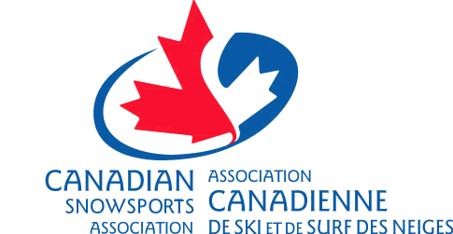

##### REQUEST FOR SANCTION

Description of sanctioned event/activity: This a yearly sanction request for allRegular Program Dates, Certification Course Dates, Division, Zone or Program Annual General Meetings (AGM's)

Division, Zone, Program Meetings, Promotional Events, Social Events, Fundraising Events beginning July 1st, 2019 to June 30th, 2020

This Form will need to be completed each year in order to be considered a sanction program under CADS. This form is not the same as the Certificate of Insurance Request (COI) which needs to be completed separately if the program has been requested for one.

###### Please refer to description of Sanctioning below

###### Event/Activity Date:

**Is this event/activity part of the yearly Schedule of activities? Yes**  **No**

***If no, please explain*** **Event which is not on the on Schedule of Activities**

**Which Club/Division is to receive the sanction for the event?**

**Event is under the control and direction of (person’s name and role in the club/organization he/she belongs to):**

**Location of the Event/Activity (include legal provincial address):**

Has ski area or other requested a certificate of insurance? Yes  No

**Has the program requested a Certificate of insurance? Yes**  **, Limit Required: $**       **No**

**CADS Division / Program requesting Sanction. (provide full legal name & Address of Office)**

     

     

     

If parties other than the certificate holder (not CSA members) are requesting to be added on as Additional Insured, please attach a list of names including description of their involvement in the event.

**Requested by:** **CSA discipline:** 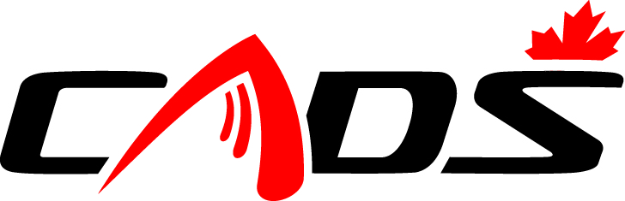

**Date:**      **Telephone No.:**     /     -      **Fax No.:**     /     -

YYYY-MM-DD

***Please do not complete the following section:***

**CADS National approval of Sanction by: _______________________________________Date: ______________**

Sanctioning is a formal process whereby an authorizing body provides its official approval for an activity to be held in that body’s name and under its jurisdiction.

• The sanctioning of an activity carries with it the obligation that the activity is carried out in accordance with the rules, policies, and procedures of the sanctioning body.

• CADS is the national sport governing body for its discipline of non- competitive para alpine skiing and snowboarding in Canada. As such CADS, on behalf of CSA, sanctions activities within its discipline that are carried out in accordance with its rules, policies, and procedures, and in accordance with CSA policy.

• Only activities normal and incidental to the discipline and controlled directly by the discipline will normally be sanctioned.

• Unusual activities, events and competitions as well as activities, events and competitions controlled, managed or supervised by third-parties (non-members) must be referred directly to the CSA.